Qingdao Qilu Sino-Canadian International School
Annual Education Results Report (AERR)

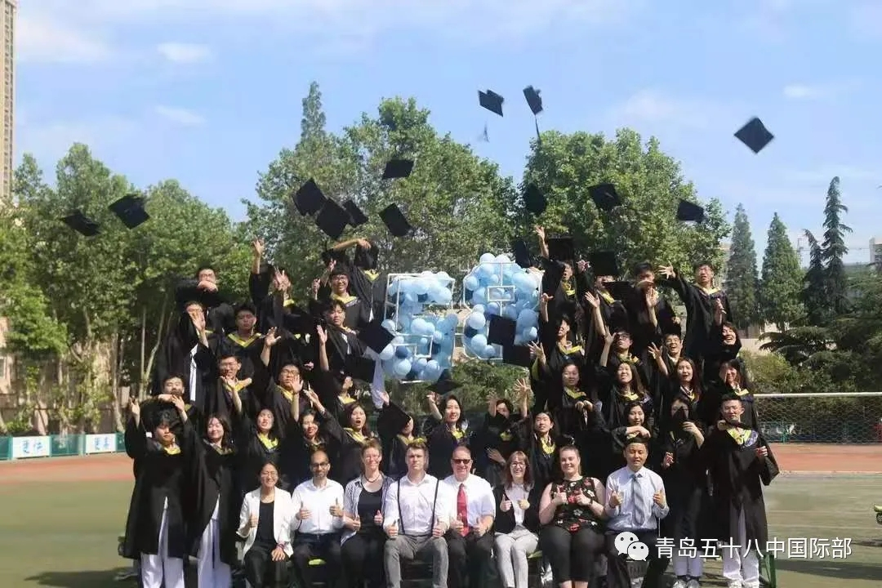

______________________________________________________________________________

School Profile

Qilu Sino-Canadian International School (Qingdao No.58 High School) is an Alberta overseas program operated by Qingdao No.58 High School of Shandong Province and the Education Department of Alberta.
Qingdao No.58 High School of Shandong Province has ranked No.1 in teaching quality in Shandong Province since 2012, which enjoys a great reputation all over China. The students in Qilu Sino-Canadian International School are among the top 10% students in Qingdao city. What’s more, their senior high school entrance examination scores were much higher than those in any other international school and international department of public schools in 2015 (over at least 57 points higher than the second best school in Qingdao).
In this program, the teaching is conducted by certified teachers authorized by Alberta in accordance with the syllabus and requirements of Alberta Education Department, using the teaching material stipulated by the Alberta curriculum. According to the requirements of the Alberta Education Department, the students can obtain a high school graduation certificate from Alberta, Canada after completing the required credits and passing the diploma exam. The Chinese courses are conducted by the teachers from Qingdao No.58 High School of Shandong Province, using the unified teaching materials in Shandong province with aims toward passing the diploma exam in Shandong province. Students will also obtain the high school graduation certificate of Shandong province after passing these diploma exams.

______________________________________________________________________________

Accountability Statement for AERR

The Annual Education Results Report for the 2021/2022 school year and the Three-Year Education Plan commencing August 30, 2021 for Qingdao No.58 High School were prepared under the direction of the Board in accordance with its responsibilities under the Private Schools Regulation and the Education Grants Regulation. This document was developed in the context of the provincial government’s business and fiscal plans. The Board approved this Annual Education Results Report for the 2021/2021 school year on November 29th, 2021.

Sincerely,
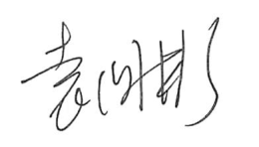
Mr. Guobin Yuan
School owner, Principal

______________________________________________________________________________

Results

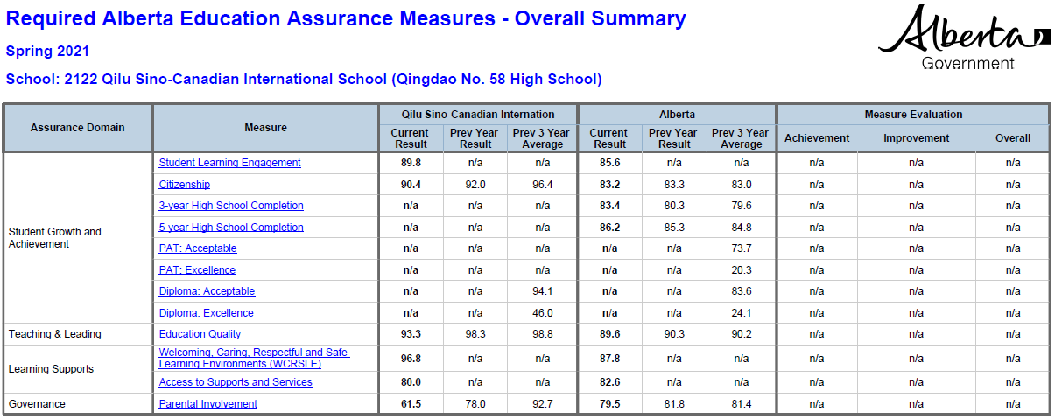

Explanation of Measures

Student Learning Engagement: Teacher, parent and student agreement that students are engaged in their learning at school.

Citizenship: Teacher, parent and student agreement that students model the characteristics of active citizenship.

Education Quality: Teacher, parent and student satisfaction with the overall quality of basic education.

Welcoming, Caring, Respectful, and Safe Learning Environment: Teacher, parent and student agreement that learning environments are welcoming, caring, respectful and safe.

Access to Support & Services: Teacher, parent and student agreement that students have access to the appropriate supports and services at school.

Parental Involvement: Teacher and parent satisfaction with parental involvement in decisions about their child's education.

Insights from Results Analysis

- Strength: In the teaching and leading domain under the measurement of education quality, the percentage of students at Qilu Sino-Canadian International have scored 93.3% as compared to the 89.6% satisfaction rate for Alberta in the current year. The three-year average is even higher for Qilu Sino-Canadian International at 98.8% compared to 90.2% for Alberta.

- Area for growth: Due to the ongoing pandemic situation, parental involvement has been more limited over the past year and a half. Parent/teacher events have been postponed or cancelled and parents have been unable to attend certain public events. We did manage to have a digital parent-teacher night recently. Also, we are adding in a parental survey that was missing last year, so hopefully this will improve current score for parental involvement which is 61.5% got Qilu Sino-Canadian International as compared to the 79.5% satisfaction rate for Alberta.

